**Title: Perform digital forensics to analyse RAM timeline using CAINE tool**

**Objective:**

The objective of this experiment is to perform digital forensics analysis on the RAM timeline using the CAINE (Computer Aided Investigative Environment) tool.

**Requirements:**

CAIN

**Procedure/Experiment Steps:**

1. Prepare the Environment: Ensure that the computer meets the system requirements for running CAINE. Install CAINE on the computer.

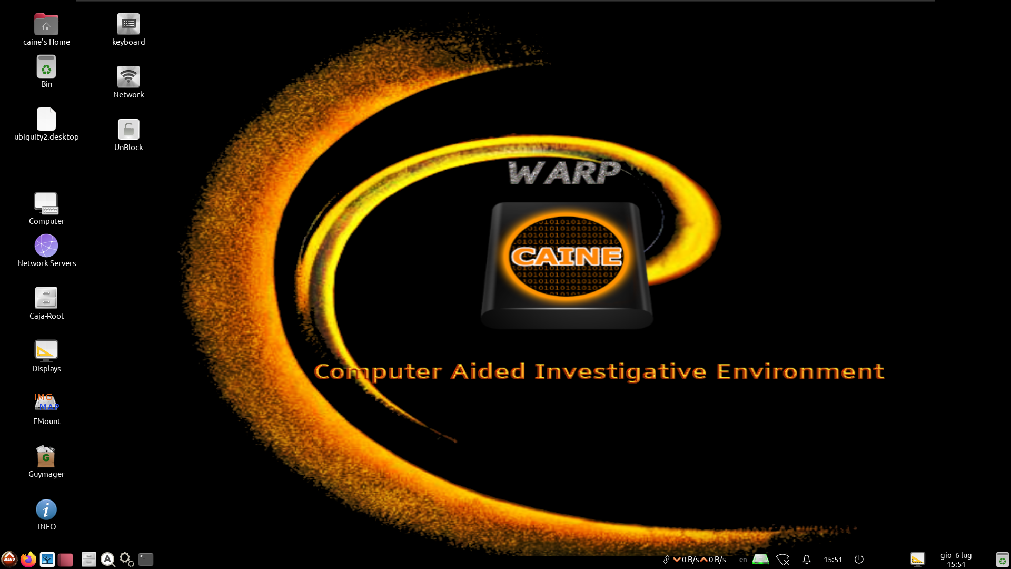

1. Analyze RAM Timeline: Use the CAINE tool to analyze the RAM timeline. This involves examining the timeline of events and activities that occurred in the RAM during the system's operation.



1. Extract Relevant Information: Identify and extract relevant information from the RAM timeline, such as processes, network connections, file accesses, or any other artifacts of interest.



1. Interpret the Timeline: Interpret the extracted information to reconstruct the sequence of events and identify any suspicious or malicious activities that may have occurred.
2. Document Findings: Record the details of the analysis, including notable events, timestamps, processes, and any other relevant findings or observations.

**Result:**

Using the CAINE tool, we successfully analyzed the RAM timeline to investigate the events and activities that occurred during the system's operation. By importing the RAM image into CAINE, we were able to examine the timeline and extract relevant information. Through the analysis, we reconstructed the sequence of events and identified any suspicious or malicious activities. The findings, including notable events, timestamps, processes, and other relevant details, were documented for further investigation and action.

**Conclusion:**

The CAINE tool proved to be an effective resource for performing digital forensics analysis on the RAM timeline. By leveraging CAINE's capabilities, we were able to explore the timeline of events and activities stored in the RAM image. This analysis plays a crucial role in identifying potential security breaches, investigating incidents, and understanding the system's behavior during a specific timeframe.

**Future Scope:**

1. Advanced artifact analysis: Dive deeper into the RAM data to extract and analyze specific artifacts, such as volatile data, cryptographic keys, or memory-resident malware.
2. Memory carving techniques: Explore CAINE's memory carving capabilities to recover deleted or obscured data from the RAM image.
3. Memory forensics automation: Investigate the automation capabilities of CAINE for memory forensics analysis, allowing for the creation of custom workflows and scripts to streamline the analysis process.
4. Integration with other forensic tools: Explore the integration of CAINE with other digital forensic tools to enhance the analysis and cross-validation of findings.
5. Research and development: Stay updated with the latest research and developments in RAM analysis techniques, tools, and methodologies to continually enhance the capabilities of CAINE in this area of digital forensics.